**Question 1**

Define the following terms:

a) Probability

b) Conditional probability

c) Mutually exclusive

d) Independent events

**Question 2**

Cyber Plastics Inc. is in search of a CEO and a CFO. The company has a short list of candidates for each position. The CEO

candidates graduated from Chicago (C) and three Ivy League universities: Harvard (H), Princeton(P) and Yale (Y). The four CFO

candidates graduated from MIT (M), Northwestern (N) and two from Ivy league universities, Dartmouth (D) and Brown (B). One

candidate from each of the respective lists will be chosen randomly to fil the positions. The event of interest is that both positions

are filled with candidates from the Ivy League.

a) Determine whether the outcomes are equally likely?

b) Determine the number of equally likely outcomes.

c) Define the event of interest

d) Determine the number of outcomes associated with the event of interest

e) Compute the classical probability of the event of interest.

**Answer:**

a) The outcomes are equal likely since all candidates have the same chance to get hired to the job.

b) The number of equally likely outcomes is the product of the number of candidates for each position: 4 CEOs × 4 CFOs = 16 possible outcomes.

c) The event of interest is that both the CEO and CFO positions are filled with candidates from the Ivy League universities.

d) To determine the number of outcomes associated with the event of interest, we need to count the number of ways to choose one candidate from Harvard, Princeton, or Yale for the CEO position, and one candidate from Dartmouth or Brown for the CFO position. There are 3 choices for the CEO position and 2 choices for the CFO position, for a total of 3 × 2 = 6 outcomes associated with the event of interest.

e) The classical probability of the event of interest is the number of outcomes associated with the event of interest divided by the total number of equally likely outcomes: P(event) = 6/16 = 0.375, or 37.5%.

**Question 3**

A construction company has submitted a bid for a government project. The project will be awarded on the basis of a blind draw.

There were 5 other bidders.

a. What is the probability that company will win the bid?

b. Suppose that there are two contracts to be awarded by blind draw. What is the probability of the company winning both?

c. What is the probability of the company no winning either contract?

d. What is the probability that the company wins exactly one contract?

**Answer:**

a) Since there are a total of 6 bidders and only one will win the bid, the probability that the company will win the bid is 1/6, or approximately 17%.

b) Since there are two contracts to be awarded and each contract is awarded by blind draw, the probability of the company winning both contracts is the product of the probabilities of winning each contract individually. The probability of winning the first contract is still 1/6, and the probability of winning the second contract is also 1/6, since each draw is independent of the other. Therefore, the probability of the company winning both contracts is (1/6) × (1/6) = 1/36, or approximately 2.78%.

c) The probability of the company not winning either contract is the complement of the probability of winning at least one contract. The probability of winning at least one contract is equal to 1 minus the probability of winning neither. Since there are two contracts and each contract is awarded independently, the probability of not winning either contract is the product of the probabilities of not winning each contract. Therefore, the probability of not winning either contract is (5/6) × (5/6) = 25/36, or approximately 69.44%.

d) The probability that the company wins exactly one contract is the sum of the probabilities of winning the first contract and not winning the second contract, plus the probabilities of not winning the first contract and winning the second contract. Since each contract is awarded independently, the probability of winning one and not the other is the product of the probability of winning one and the probability of not winning the other. Therefore, the probability of winning exactly one contract is (1/6) × (5/6) + (5/6) × (1/6) = 10/36, or approximately 27.78%.

**Question 4**

The college basketball team at WTS University has 10 players: 5 seniors, 2 juniors and 3 sophomores. Two players are randomly

selected to serve as captains for the next game. What is the probability that both players selected are seniors?

**Answer:**

There are a total of 10 players on the team, so there are 10 choices for the first captain and 9 choices for the second captain (since one player has already been chosen). The number of ways to choose 2 seniors out of the 5 seniors is given by the combination C(5,2), which is the number of ways to choose 2 objects out of 5. The total number of ways to choose 2 players out of 10 is given by the combination C(10,2), which is the number of ways to choose 2 objects out of 10. Therefore, the probability of selecting 2 seniors as captains is:

P(2 seniors) = C(5,2) / C(10,2) = (54 / 21) / (109 / 21) = 10/45

So, the probability that both players selected are seniors is 10/45, or approximately 0.2222.

**Question 5**   
Suppose a quality manager for Dell computers has collected the following data on the quality status of disk drives by suppliers.   
She inspected a total of 700 disk drives.

Drive Status   
Supplier Working Defective   
A 120 10   
B 180 15   
C 50 5   
D 300 20   
   
a) What is the probability of randomly selecting a disk drive from company B?   
b) What is the probability of a defective disk drive being selected by the company?   
c) What is the probability of a defect given that company B supplied the drive?   
d) Given that the drive is working, what is the probability that it came from company D?

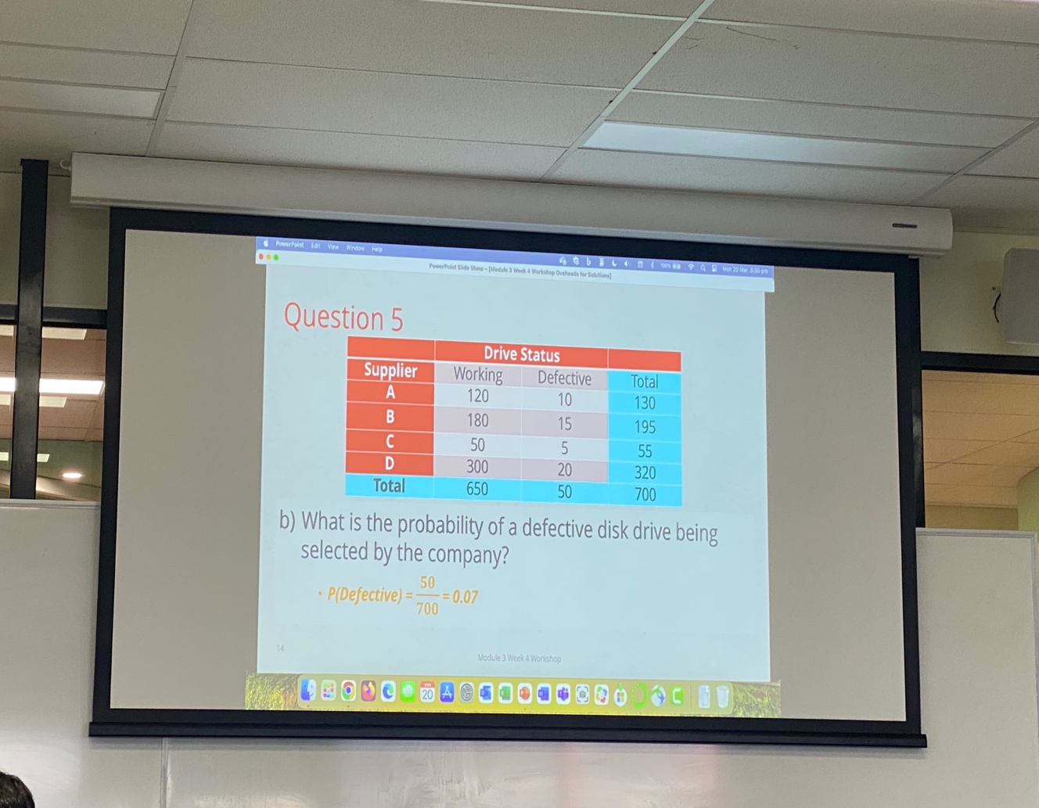**Answer:**

a) The probability of randomly selecting a disk drive from company B is the proportion of drives supplied by company B, which is:

P(B) = (180 + 15) / 700 = 195 / 700 = 0.2786

b) The probability of a defective disk drive being selected is the proportion of defective drives in the sample, which is:

P(Defective) = (10 + 15 + 5 + 20) / 700 = 50 / 700 = 0.0714

c) The probability of a defect given that company B supplied the drive is the proportion of defective drives among the drives supplied by company B, which is:

P(Defective | B) = 15 / (180 + 15) = 0.0779

d) The probability that it came from company D is:

P(D | Working) = $\frac{P(Working and D)}{P(Working)}$ = $\frac{300/700}{650/700}$ = 300/650 = 0.4615